Raspberry pi 3 SPI

We are going to use buildroot and write an SPI test between rapberry pi 3 to Kinetis K64.

The documents on K64 can be found here at my Giyhub.

https://www.raspberrypi.org/documentation/hardware/raspberrypi/spi/README.md

The Raspberry Pi is equipped with two SPI bus that has 2 chip selects.
The SPI master driver is disabled

When the image is ready there is a filename
output/images/rpi-firmware/config.txt

To add the dtparam spi to this file, can edit the filename
package/rpi-firmware/config.txt
and add it there:

dtparam=spi=on

make sure that after the build completed the file output/images/rpi-firmware/config.txt does have the dtparam=spi=on

This is the device tree change :)

The SPI bus is available on the P1 Header:

SCLK - Serial Clock
CE - Chip Enable (often called Chip Select)
MOSI - Master Out Slave In
MISO - Master In Slave Out
MOMI - Master Out Master In

MOSI P1-19
MISO P1-21
SCLK P1-23
GND P1-25
P1-24 CE0
P1-26 CE1

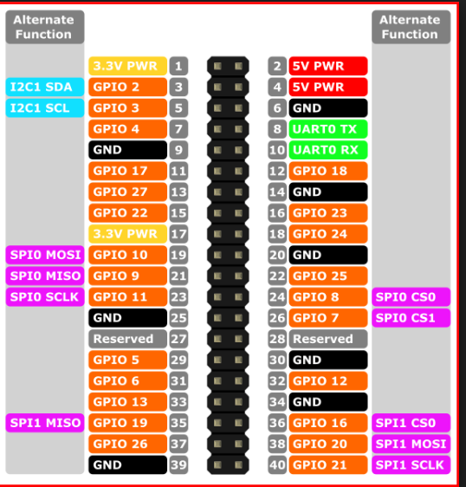

we can use pin 6 for common ground.

LINUX DRIVER
The default Linux driver is spi-bcm2835

Buildroot:

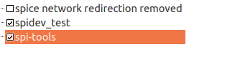

Does the SPI driver module is already define in the Linux kernel?

We can check ,
make linux-menuconfig
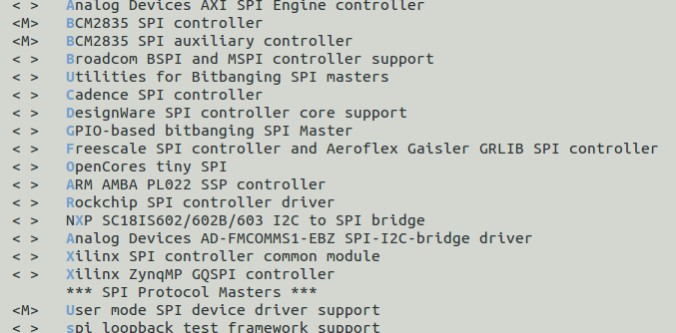
We also see that the driver is BCM2835 and not bcm2708
So probably the documentions is for the PI2 ,
Once we built the buildroot image , we can see the driver that was added and we can modprobe it.

So in:
/lib/modules/4.9.21-v7/kernel/drivers/spi
We have the module

spi-bcm2835.ko and the spidev.ko

let's modprobe both
modprobe spidev
modprove spi-bcm2835

Doing those three steps ( dtparam and modprob)
We can see now the /dev/spidev0.1

This document is on conjunction to the beaglebone SPI test that I am doing,
In Raspberry it is much easier to define

So we can use the same environment and compiler

BBB_C_COMP=/mnt/b/buildroot/bbb_processor_sdk/buildroot-2017.05.1/output/host/usr/bin export PATH=$PATH:$BBB_C_COMP
And the Makefile:
CC = arm-linux-gnueabihf-gcc
SRC=$(wildcard *.c)
spitest: $(SRC)
$(CC) -o $@ $^ $(CFLAGS) -I$(INCLUDE) -L$(LIBS)
clean:
rm *.o spitest

or:

CC = arm-linux-gnueabihf-gcc

spitest : spitest.c
$(CC) -o $@ $^ $(CFLAGS) -I$(INCLUDE) -L$(LIBS)

clean:
rm *.o spitest.c

Connection:

PI 23 (CLK) → K64 J2 Pin 12(CLK) → Yellow
PI 24 (SPI1_CS0) → K64 J2 Pin 6(CS) → Orange
PI 19 (MOSI) → K64 J2 Pin 8(MOSI) → Red
PI 21 (MISO) → K64 J2 Pin 10 (MISO) → White
PI 6 (Ground) → K64 J2 Pin 14( Ground) → Black

C code.

The important thing is the mode : SPI_IOC_RD_MODE

int mode = 0;
int ret = ioctl(fd, SPI_IOC_RD_MODE, &mode);
if (ret == -1)
{
perror("can't get spi mode");
exit(1);
}
mode = 0;
printf ("new SPI mode: %d\n" , mode);
ret = ioctl(fd, SPI_IOC_WR_MODE, &mode);
if (ret == -1)
{
perror("can't get spi mode");
exit(1);
}

After some trying , I found that the mode should be 0 , means no clock polarity and no clock phase.
The default btw was 3 , both polarity and clock phase.

Once doing that , the write received at the K64 side.

To develop high level driver above the SPI is not in the scope of this project.
I prefered working directly at the interrupt level , getting the data into fifo and parse it on the main loop like in the I2C.

